A automate refinement workflow has been proposed by our WISDOM partners in Taiwan who are involved in the Avian Flu data challenge.

Find below theirnotes on this topic.

“Biologists usually adopt a virtual screening pipeline (showing in Figure 1) to narrow down the number of interesting ligands. In this approach, a cycle of “screening – filtering – screening” is needed. However, current implement focuses mostly on how to distribute docking jobs rather than pipeline automation.”

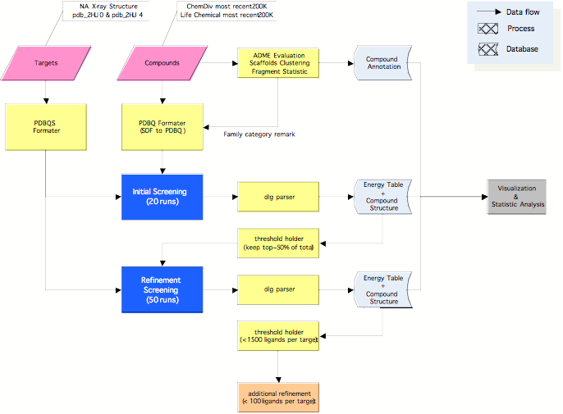
Figure 1 the refinement pipeline of virtual screening

